**Thruster Report**

|  |  |
| --- | --- |
| **Thruster Ratio:** | **1.200** |
| **Magnetic Field:** | **750 mT** |
| **Anode Power:** | **1419 W** |
| **Anode Current:** | **6.0 A** |
| **Anode Energy:** | **93042.9 J** |
| **Propellant:** | **Argon 0.500 mg/s** |

**Thruster Details: Nagoya magnet, LaB6 cathode, 1 mm orifice, copper anode, 80 mm internal diameter. CoM correction method: Anode Energy, Pre-offset 0.0 s, Post-offset 100.0 s, Cold-Gas thrust 0.1 mN**

|  |  |  |  |  |  |  |
| --- | --- | --- | --- | --- | --- | --- |
| Thrust | Thrust Eff. | ISP | Total DOF | Coverage Factor | Exp. Uncertainty | Std. Uncertainty |
| 22.5 mN | 35.5 % | 4577.8 sec | 6 | 2.18 | 7.7 mN | 3.5 mN |

**Thrust-Stand Uncertainty Components**

|  |  |  |  |  |  |  |  |
| --- | --- | --- | --- | --- | --- | --- | --- |
|  | Weights | Scale | Hysteresis | Repeatability | Noise | Offset | Drift |
| Value | 0.0 mN | 0.9 mN | 0.6 mN | 0.2 mN | 1.8 mN | 0.8 mN | 2.7 mN |
| DOF | 30 | 4 | 8 | 18 | 29 | 2 | 2 |

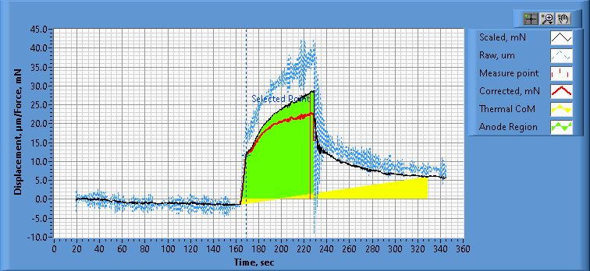

**Figure 1. Thrust Plot**

File Name: Philtech Data 2025.04.15_21.59.16.csv

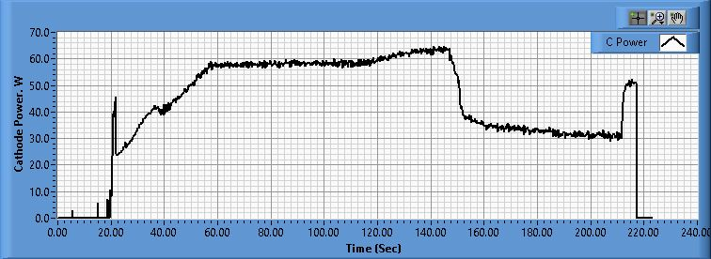

**Figure 2. Cathode Power Plot**

File Name: PSU C Data 2025.04.15_21.59.33.csv

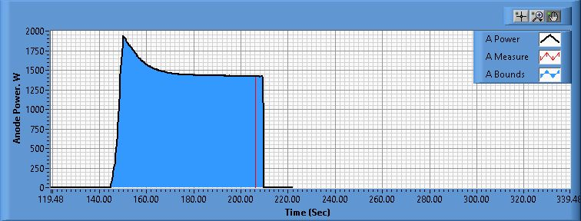

**Figure 3. Anode Power Plot**

File Name: PSU A Data 2025.04.15_21.59.35.csv

**Pre-Cal. Information**

File Name: Philtech Data 2025.04.15_16.30.51.csv

Start/Stop times (24 h): 16:30:58 16:32:53

Sensitivity: 1.58 um/mN

|  |  |  |  |
| --- | --- | --- | --- |
| Offset | Drift | Scale Factor | Scale Std.Dev |
| -0.981 mN | -0.062 mN/s | 0.633 | 1.318 mN |

Plateau values:

|  |  |  |  |  |  |  |  |  |  |  |
| --- | --- | --- | --- | --- | --- | --- | --- | --- | --- | --- |
| Weight 0 | Weight 1 | Weight 2 | Weight 3 | Weight 4 | Weight 5 | Weight 4 | Weight 3 | Weight 2 | Weight 1 | Weight 0 |
| -1.1 mN | 20.8 mN | 38.3 mN | 59.0 mN | 78.5 mN | 100.8 mN | 79.2 mN | 59.4 mN | 39.5 mN | 21.9 mN | 0.9 mN |

**Post-Cal. Information**

File Name: Philtech Data 2025.04.15_21.59.16.csv

Start/Stop times (24 h): 22:05:52 22:07:50

Sensitivity: 1.55 um/mN

|  |  |  |  |
| --- | --- | --- | --- |
| Offset | Drift | Scale Factor | Scale Std.Dev |
| -6.129 mN | -0.066 mN/s | 0.647 | 1.291 mN |

Plateau values:

|  |  |  |  |  |  |  |  |  |  |  |
| --- | --- | --- | --- | --- | --- | --- | --- | --- | --- | --- |
| Weight 0 | Weight 1 | Weight 2 | Weight 3 | Weight 4 | Weight 5 | Weight 4 | Weight 3 | Weight 2 | Weight 1 | Weight 0 |
| -0.4 mN | 21.2 mN | 38.4 mN | 58.6 mN | 78.8 mN | 101.1 mN | 78.7 mN | 58.9 mN | 38.9 mN | 21.5 mN | -0.3 mN |